Fast**National University of Computer and Emerging Sciences, Karachi  
Department of Computer Science**

**Spring 2021, Midterm 1  
 March 20, 2021, 11:15 am – 12:15 pm**

|  |  |  |
| --- | --- | --- |
| **Course Code: CS 422** | **Course Name: Human Computer Interaction** | |
| **Instructor Name : Mr. Behraj Khan** | | |
| **Student Roll No:** | | **Section No:** |

* Return the question paper.
* Read each question completely before answering it. There are **8 questions and** **2 pages only.**
* In case of any ambiguity, you may make assumption. But your assumption should not contradict any statement in the question paper.
* Each question carries five points
* Figures are given at page 2

**Time**:  60 minutes.                                                                                                **Max Marks**: 40 points

Q1. Design principles, guidelines and standards are design rules to enhance the usability of an application, justify the distinction between design principles, guidelines and standards. You are required to point out the concept of **Substitutivity** design principle applied in figure 1. CLO1

Solution: principles are abstract design rules low in authority and high generality while standards are specific design rules high in authority and limited application. Guidelines lower authority more general application.

Substitutivity: allowing equivalent values of input and output to be substituted for each other, representation multiplicity; equal opportunity

Q2. How can metaphor maximize the usability of an interactive system? Consider figure 1 and list down at least five metaphors used on the screen. Explain how it will help the user. CLO3

Solution: Mapping the real world activities into computing world which helps user in interaction.

Metaphors are: recycle bin, calendar, movie player, settings, calculator.

Q3. As you are required to submit a semester project in HCI. If you are asked about the selection of prototyping model for your project, what will be your answer? Justify. CLO3

Solution: Depends on student selection prototyping model.

Q4. Consider the screen given in figure 1 and explain how the concept of task adequacy is applied? How it will be helpful for users? CLO3

Solution: task adequacy is applied with the help of “familiarity”. User previous experience with other applications can help here.

Q5. Differentiate between slips and mistakes, how can each be minimized for a given application. CLO3

Solution: right intention but incorrect actions results in slips, while wrong intention cause mistakes, slips can be minimized by better user interface and mistakes can be minimized by tutorials.

Q6. In some cases implementation of “error prevention” is mandatory. Write down an example where the mention concept is applied along with description of the mention concept. CLO1

Sol: when creating new account at gmail and we are looking for available user name.

Q7. The concept of recognition discriminates the command line interface and graphical user interface based system? How the mentioned concept helps the user. CLO3

Sol: The user real world experience helps user in interaction by looking into icons and images which applied in recognition.

Q8. Draw the graphical issue based information system design rationale for the figure 2 while considering the phone unlocking scenario as discussed in class.CLO2

Sol:

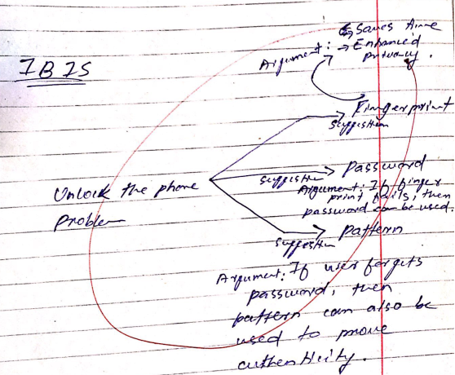

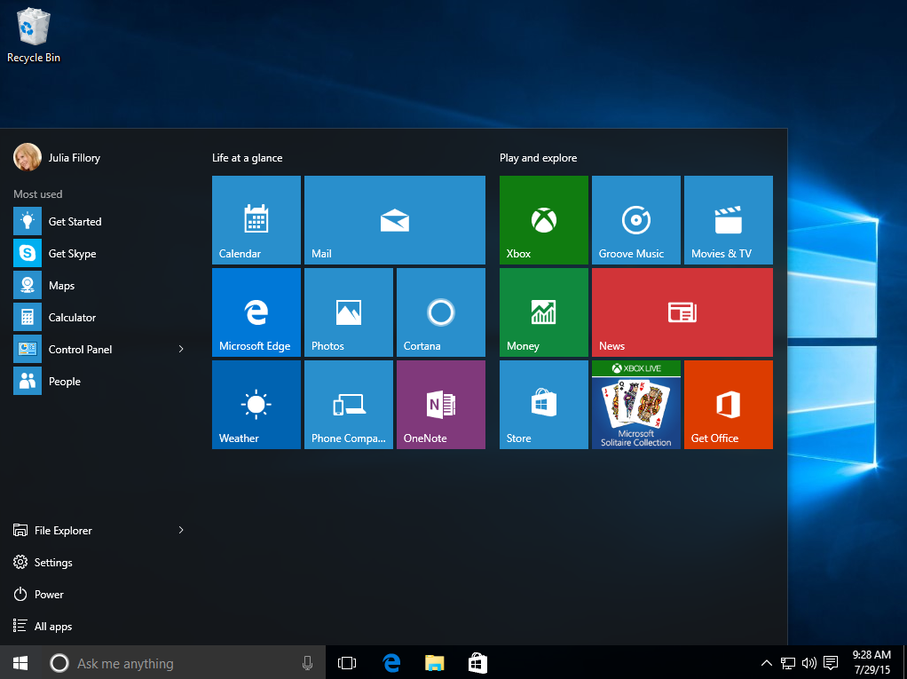

**Figure 1**

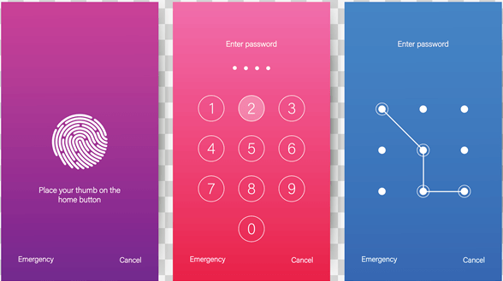

**Figure 2**